Steps to Install Ubuntu
On a Flash Drive

Requirements:
- Ubuntu Installation DVD
- 8 Gb Flash Drive
- A computer that supports boot from USB disk

Installation:
- Installation DVD gets booted and you will get the below screen. Select the Install Ubuntu

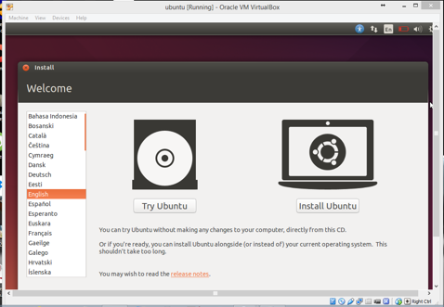

- Select the option “I want to manually reboot later”

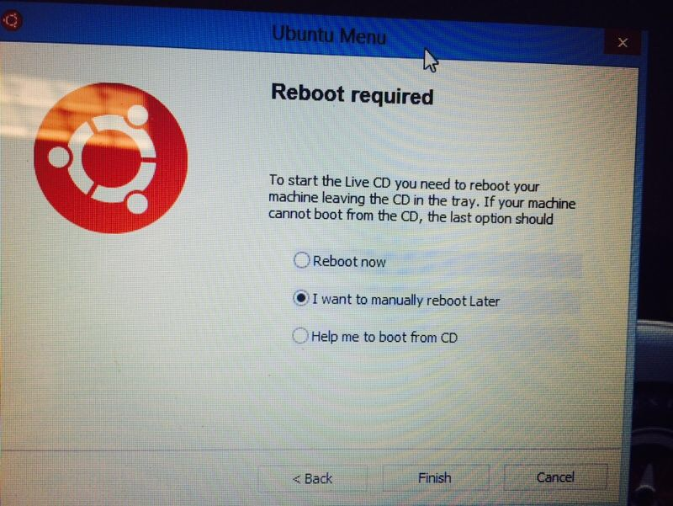

- Click continue in the below screen

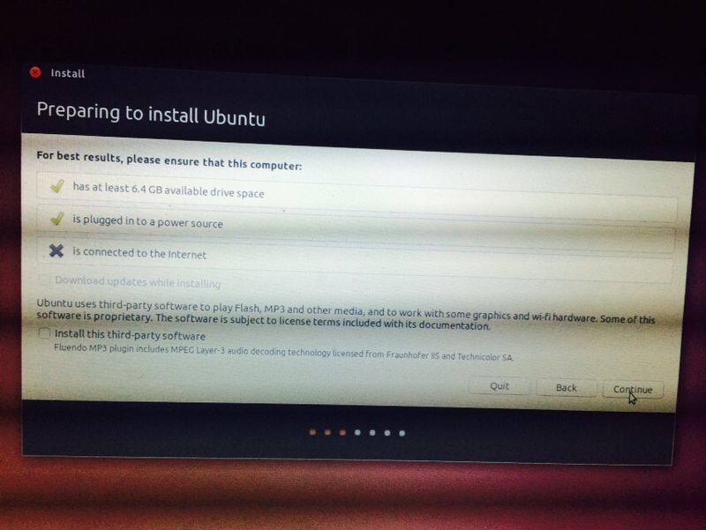

- Check “Something else” option in the Installation type screen

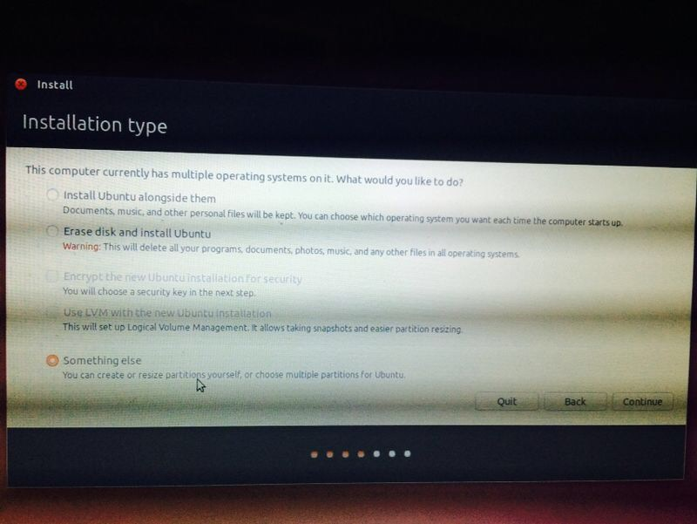

- Select the flash drive devise under /dev/sdb

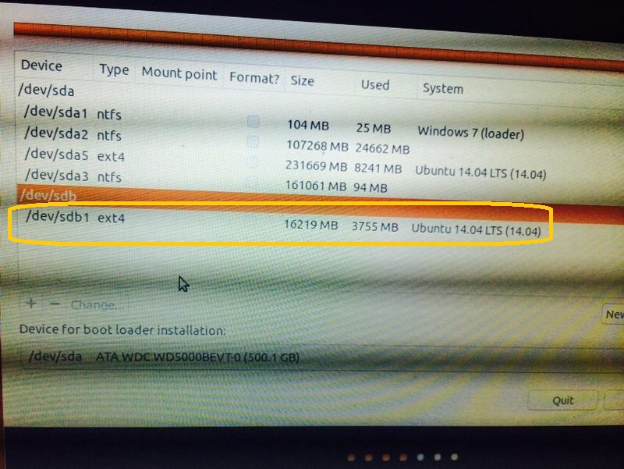

- Make sure that the type is “ext4 journaling file system”. You can select this from “change” option.

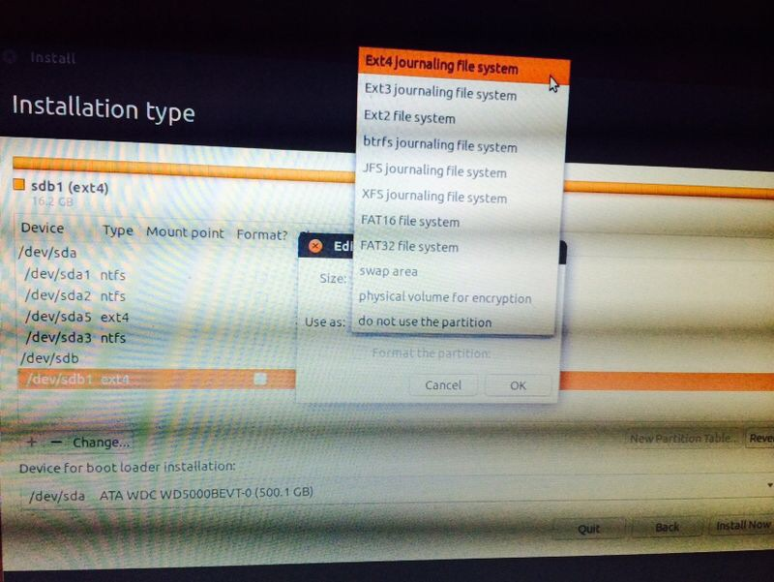

- Change the partition size as required and make sure you select Mount point as root ”/”

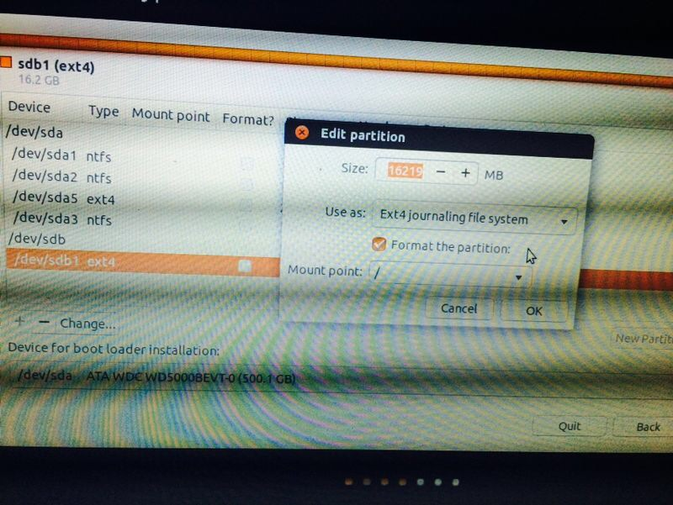
- Select the flash drive under Device for boot loader Installation and click Install.

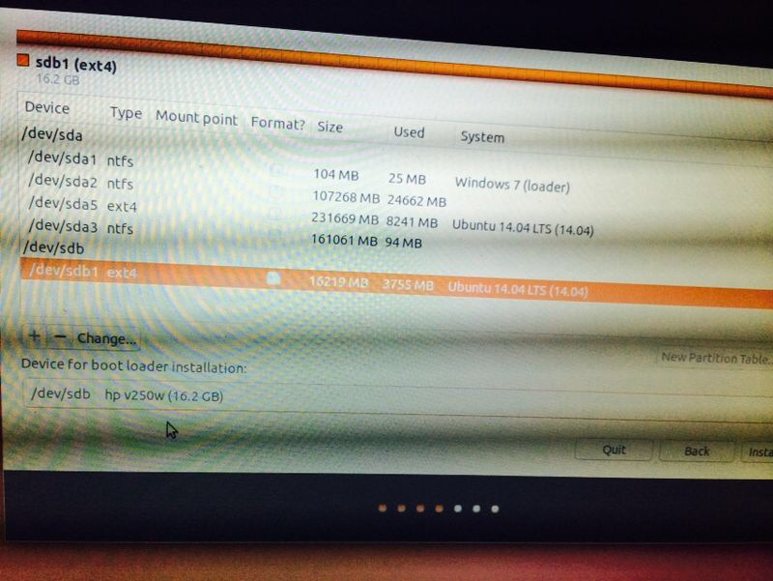

- Continue with the Installation, It asks general information like Geographical location, Language etc. Complete the information.
- Once the installation is completed, you can remove the DVD and restart the computer with your flash drive plugged in. You are ready to work on Ubuntu using your flash drive.

